COMMO PAD
a multifunctional
C64 / USB touchpad

C64 : KoalaPad / paddle
joystick
3 button 1351 mouse
USB : 2 button + scrollwheel mouse

this manual is intended for
firmware version: V20191210 or higher

By: Jan Derogee (2019)

Introduction
This device consists of an Arduino Pro Micro and a 4-wire resistive touchpad. Because the Pro Micro has USB, the device can function like a HID device. In this case a 2-button+scrollwheel mouse. No drivers are required because the PC recognizes this device as a regular mouse.

However the intention of this device is not to act like a USB mouse but to function as a C64 KoalaPad or as a 1351 mouse. It can also act like a joystick, but that's not really a practical application. The device operates in one of these modes depending on the power source (USB or joystickport) and the selected configuration (KoalaPad/joystick/1351 mouse).

You might wonder why somebody would make such a project. Well… I wondered if it would be possible to build a KoalaPad with modern components and the answer is: YES, you can make a device that works exactly like a KoalaPad using modern components.

Table of Contents
1 Introduction 4
1.1 What is a koalapad 4
1.2 What is a joystick 5
1.3 What is a 1351 mouse 6
2 System setup 7
3 Modes of operation 8
3.1 USB mouse mode 8
3.2 Koalapad mode 8
3.3 Joystick mode 8
3.4 1351 mouse mode 8

Introduction

What is a koalapad
The KoalaPad is a graphics tablet produced from 1983 by U.S. company Koala Technologies for the Apple II, TRS-80 Color Computer (as the TRS-80 Touch Pad), Atari 8-bit family, and Commodore 64, as well as for the IBM PC. Considering I really like the C64, I made this project for the C64.

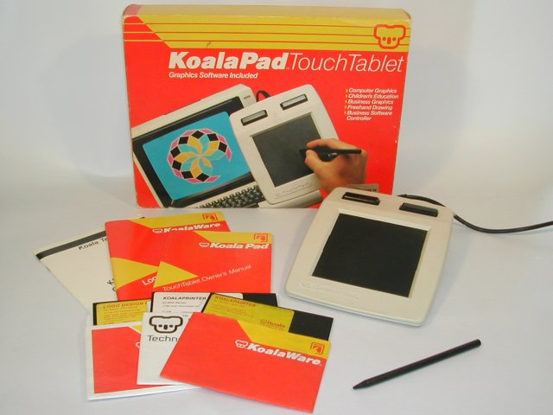
Originally designed by Dr. David Thornburg as a low-cost computer drawing tool for schools, the KoalaPad and the bundled drawing program, KoalaPainter, was popular with home users as well. KoalaPainter was called KoalaPaint in some versions for the Apple II, and PC Design for the IBM PC. A program called Graphics Exhibitor was included for creating slideshow presentations from KoalaPainter drawings.

Technically, the koalapad acts like a set of paddles. But in order to do so it requires some fancy electronics, it converts the measured touchscreen position into a digital signal that makes the CBM computer think an ordinary analog paddle is connected. So if you have a drawing program that can handle the koalapad, it then can also handle normal paddles, meaning that you can mount your paddles on a board and pretend you have an etch-a-sketch like input device. Because one paddle acts like the X input and the other as the Y input. Although this does work, this is a far practical application for paddles.

The koalapad is an absolute pointing device. The position or values it generates on the POT-X and POT-Y signals as read by the C64 range from 0,0 (top left) to 255,255 (bottom right). This device is very practical for drawing applications.

What is a joystick
A joystick is a set of switches (1 switchs acte like a select/fire button and the other 4 are for the directions N-S-E-W). This means that eight directions can be generated. Therefore this device is also referred to as a digital joystick (the switches used are either on or off). The direction switches are mounted to a comfortable stick. Although joysticks were mainly intended to be used on arcade cabinets they quickly entered the homes during the age of home computing in the 80's. No matter if you bought a cheap or an expensive one, they all worked the same in principle. For drawing applications this is not the most desirable input device.

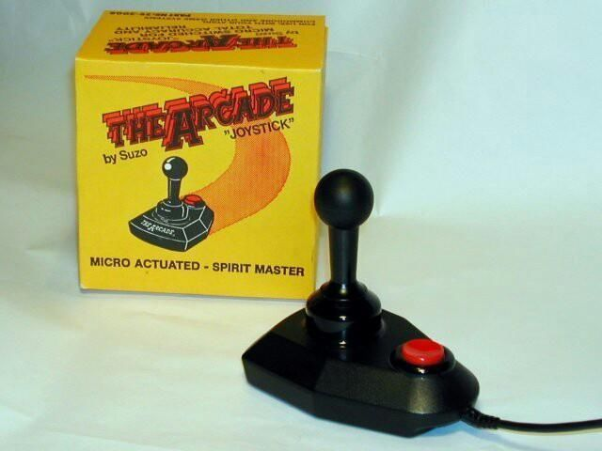

What is a 1351 mouse
The 1351 mouse is the one and only mouse from Commodore (there is also the Commodore 1350 mouse, but that is a device that only looks like a mouse, in practice it acts like a joystick and therefore it cannot detect speed variations. Therefore the 1350 mouse doesn't feel like a true mouse at all and therefore should not be even considered as a mouse. The 1351 mouse is a true mouse in that it can handle all the regular movements that are expected from a mouse, it tracks the users hand very accurately. Although the mouse is a huge improvement over the joystick, when it comes to drawing applications, it doesn't compare to the realism of a touchpad or drawing tablet like the koalapad.

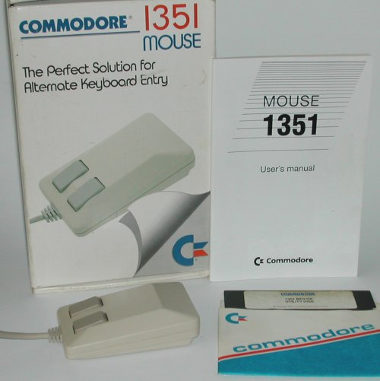
The 1351 mouse, just like the KoalaPad, uses the pot-X and pot-Y signals of the joystick port, meaning that the X and Y positions are send in an analog manor, faking the signals as if a paddle was connected. Although this doesn't mean that you can use paddles instead of a 1351 mouse, because the range of the mouse is far greater then the paddle range would allow. Therefore there are some tricks the 1351 mouse uses that cannot be replicated by an ordinary paddle.

System setup
The device has 2 ports, a USB port and a joystick port. It has a touchsurface, this should be used in combination with a blunt object like a special plastic pen (this is refered to a pointing device in this manual). Do not use any sharp object as you will damage the surface. Don't use your fingers, although it does seem to work, it doesn't work reliably.
The device has 3 buttons, these are named button-1, button-2 and button-3 in this document.
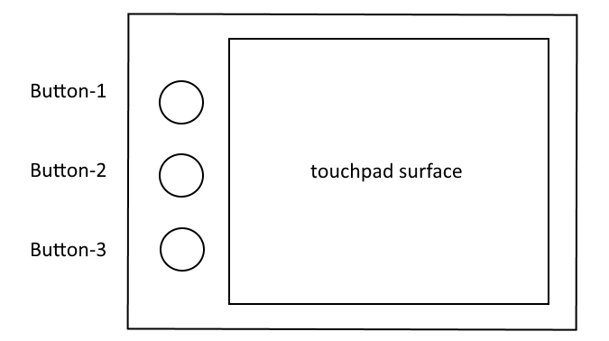
Plug the device into your PC's USB port if you want to use it an USB mouse. The USB connector is on the left side of the back of the COMMO PAD.
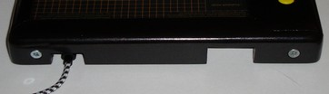
Plug it into the joystick port of your C64 and you can use it as a KoalaPad, joystick or 1351 mouse. The joystick connector is on the right side of the back of the COMMO PAD.
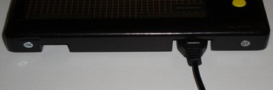
The touchpad's background isn't only black, it has some helpful gridlines and the most important information required for configuration. This way you can use it (configure it) without reading the manual. However if something happens to this background or you which to modify it to your own needs (perhaps for making a more practical center indicator to use for the difficult joystick mode).

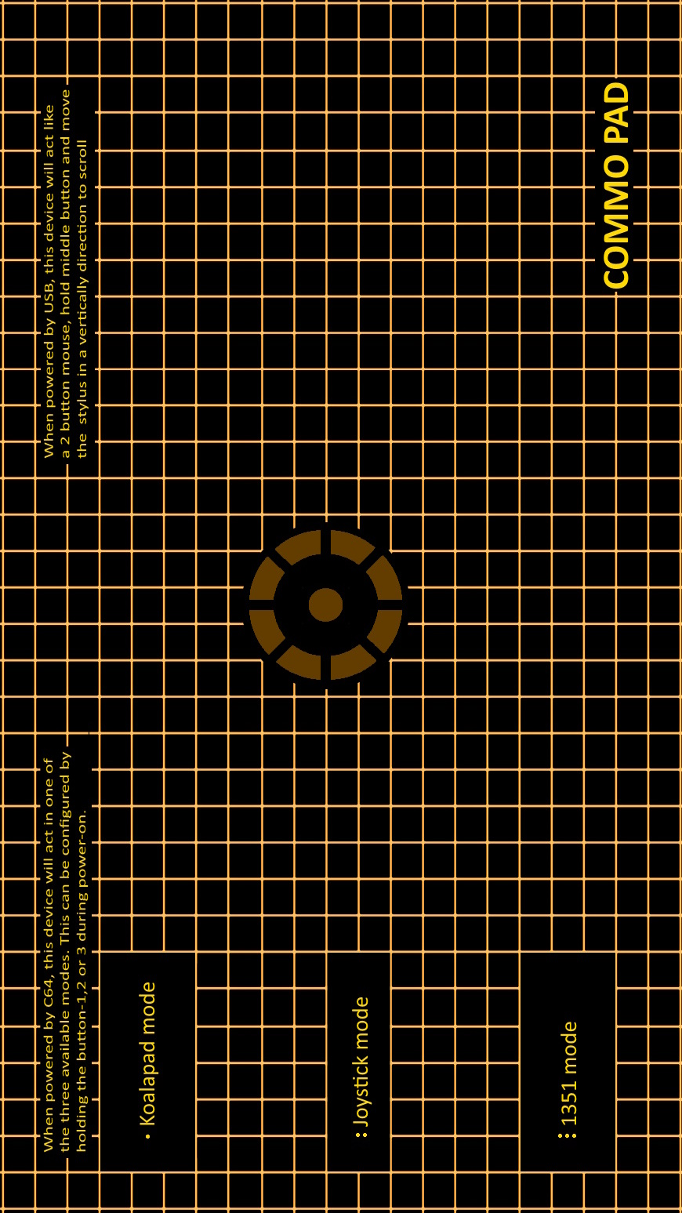

Modes of operation

USB

USB mouse mode
The device can act like a USB 2-button + scrollwheel mouse. All you need to do is connect the device using the USB cable to your PC. No software needs to be installed. Make sure that the 9-pole joystick port connecter is not used/connected.
When you move your pointing device over the surface of the panel you'll notice that the movements are relative, you can place the pointing device anywhere on the touchpad and move in any direction and the mousepointer on omputerscreen will move accordingly. You can lift the pointing device without affecting the mousepointer. It may be fun to know that you can use it in combination with your regular PC mouse and therefore benefit from best of both worlds, your normal mouse and your touchpad.

Button-1 = left mouse button
Button-2 = scrollwheel (push button, then moves the stylus in a vertical direction on touchpad)
Button-3 = right mouse button

C64

KoalaPad mode
The device can also act like a KoalaPad. All you need to do is to configure it once to make use of this mode. You can do this by:
- connecting the device to the joystick port of your CBM
- hold button-1
- switch your CBM on
- wait until you hear a beep
- release the button
- the pad is now configured as a KoalaPad, this setting is saved automatically.

When in KoalaPad mode, the pad beeps one time, to indicate that this mode is active.
When you move your pointing device over the surface of the panel you'll notice that not the entire panel can be used, this because the panel is based on a wide-screen display panel. Therefore it isn't as square as the original KoalaPad. However this doesn't really matter during use. All movements on the surface of the panel are absolute. The center of the touchpanel generates a position of 128,128.
Button-1 = left koala button
Button-2 = undefined
Button-3 = right koala button

Joystick mode
The device can also act like a joystick. All you need to do is to configure it once to make use of this mode. You can do this by:
- connecting the device to the joystick port of your CBM
- hold button-2
- switch your CBM on
- wait until you hear a beep
- release the button
- the pad is now configured as a joystick, this setting is saved automatically.

When in joystick mode, the pad beeps two times, to indicate that this mode is active.

When you move your pointing device over the surface of the panel for a certain distance to the left, you'll activate the joystick-left switch. By moving right or lifting the pointing device the joystick-left switch is deactivated. On the device is a small marker that indicates the center of the touchpad as well as a circle indicating the movements to be made in order to make the device act like a joystick. Although this mode does work, it cannot compete with a real joystick when it comes to practical functionality.

Button-1 = fire button
Button-2 = fire-button with auto-fire function
Button-3 = fire button

1351 mouse mode
The device can also act like a 1351 mouse. All you need to do is to configure it once to make use of this mode. You can do this by:
- connecting the device to the joystick port of your CBM
- hold button-3
- switch your CBM on
- wait until you hear a beep
- release the button
- the pad is now configured as a 1351 mouse, this setting is saved automatically.

When in 1351 mouse mode, the pad beeps three times, to indicate that this mode is active.
When you move your pointing device over the surface of the panel you'll notice that the movements are relative, you can place the pointing device anywhere on the touchpad and move in any direction and the mouse pointer on computer screen will move accordingly. You can lift the pointing device without affecting the mouse pointer.
Button-1 = left mouse button
Button-2 = undefined
Button-3 = right mouse button

Schematic


